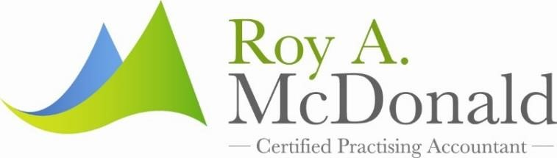

ROY A MCDONALD 2017 INDIVIDUAL TAX CHECKLIST

Income from Working/Pensions
Group certificates & PAYG payment summaries
Lump sum payments eg: Eligible Termination
Centrelink, social security, pensions, allowance documents and statements

Deductions
Receipts of work related deductions eg. Clothing/ tools/car/logbook/mobile phone/subscriptions
Receipts of gifts/donations to charities
Receipts of self-education expenses eg. Books /computer costs/car expenses
Last Year’s tax fees & ongoing financial planning advice fees
Income Protection Premiums

Income from Investments
Bank interest and statements
Trust distribution statements
Managed Fund investments annual statements
Share dividend statements
Buy/sell notes for share trades
Capital Gains Tax statements
Tax statements from stockbroker/financial planner

Deductions
Interest on borrowing for investment purposes
Asset purchase/loan agreements
Asset sale documents

Income from Overseas
Foreign salary/wage income received
Foreign tax paid
Foreign rental property income
Foreign rental property expenses
Foreign investment income
Foreign pensions received

Other useful information
Credit card statements
Centrelink and Child Support Agency debts
HELP, HECS, or SFSS debt balances
Superannuation co-contributions
Child support paid by you and your spouse
Private Health Insurance Rebate Statement

Your tax return cannot be lodged without the correct information being disclosed. Note: the amount of the private health insurance rebate entitlement will vary depending on which income threshold tier the individual falls into – this is based on the individual’s income (either as a single or family) and their age. Broadly, singles and families will not be entitled to any private health insurance offset where the income for surcharge purposes is $140,001 or $280,001 for singles and families for the 2016 year.

Obtain details of net medical expenses
(out of pocket > $2299) - This offset has changed. Expenses you can claim are restricted to the following disability aids, attendant care or aged care. You can only claim this offset if you had expenses that relate to disability aids, attendant care and aged care. Disability aids are items of property manufactured as, or generally recognised to be, an aid to the functional capacity of a person with a disability but, generally, will not include ordinary household or commercial appliances. Attendant Care expenses relate to services and care provided to a person with certain disabilities to assist with everyday living, such as the provision of personal assistance, home nursing, home maintenance, and domestic services to a person who is blind or permanently confined to bed or a wheel chair. Aged care Expenses relate to services and accommodation provided by an approved aged care provider to a person who is a care recipient or continuing care recipient within the meaning of the Aged care Act 1997. Eligible expenses include payments:
- to a carer who looks after a person who is blind or permanently confined to a bed or wheelchair • for disability aids prescribed by a doctor
- for artificial limbs or eyes and hearing aids
- for maintaining a properly trained dog for guiding or assisting people with a disability (but not for social therapy) • for residential or in-home aged care expenses.

Spouse Income Details –
If your spouse’s tax return is not prepared by this office, please provide the following income details for your spouse as your tax return cannot be lodged without the information being provided on your tax return

- Taxable Income
- Reportable Employer Superannuation Contributions
- Reportable Fringe Benefits
- Tax Free Govt pensions
- Other exempt pension income

If you have an Investment Property (Contact our office for a schedule/checklist)

If you have Income from Business (contact our office for a schedule/checklist)

If you have Capital Gains (Contact our office for a schedule/checklist)

Please complete and return with all relevant documentation:

Cash Book/ Invoice Book/ Profit & Loss
PAYG instalments and BAS Statements
Bank statements for financial year

Expenses
Tools & Materials
Home Office Expenses
Insurance
Rent on business premises
Wages and payments to contractors
Vehicle Expenses (if applicable to business)
Other business costs eg. Advertising/ stationery & printing/ bookkeeping etc

Other Deductions
Superannuation contributions
Financing lease statements
Income protection premiums
Prior year tax losses

By signing this document you confirm that you believe that you can prove the expenses that you wish to claim in your tax return; and that you understand that you could be fined for lodging a false tax return.

Your Name: …………………………………………… ……………………………………………………………

--------------------------------------------------------------------------------------------------------------
Signature of Taxpayer

Dated the …… day of ………………………201……

